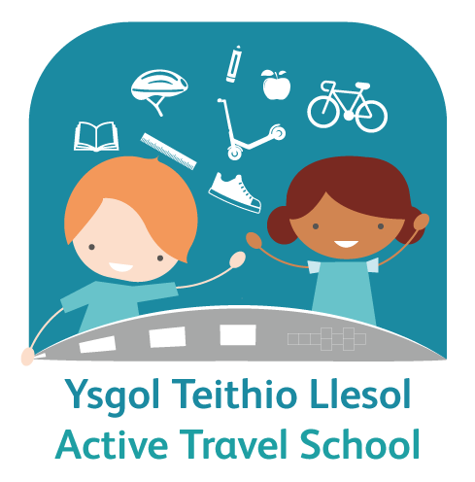



Active Travel School

GDPR Consent form for Videos

About the scheme

Cardiff Council is supporting schools to explore alternatives to car travel for the school journey.

As part of this scheme, we think it would be great to include videos about your experiences of using different ways of travelling to school. In order for us to use your videos, we require your written consent.

Your videos will be published on our website and Twitter account and viewed by members of the public. For further information, please refer to our privacy notice here keepingcardiffmoving.co.uk/schools

Video Consent:
If you are under the age of 13, a parent/guardian will be required to consider and sign the below on your behalf.

Please tick the boxes below to indicate if you agree to the following;

I agree to the processing of my information by Cardiff Council in order to ☐
share my experience with the public

I agree to the video being posted on Active Travel Schools Twitter account ☐
I agree to my video being uploaded onto the www.keepcardiffmoving.co.uk website ☐

I agree to receive Cardiff Council Communications from travelplans@cardiff.gov.uk email regarding the video ☐

Terms of use

- Consent is valid for 2 years and automatically expires after this time. If you wish to withdraw your consent, you can do so at any time by contacting travelplans@cardiff.gov.uk and we will deal with your request as soon as possible.

- Your videos will only be uploaded to our website and will not be used for any other purpose.

- We will not include details or names of any child or adult in any of the videos used, promotional material or in printed publications without consent.

- We will not use the videos for any other purposes than those mentioned above.

- Your video will not be processed or shared with any third parties.

- Copyright of any photograph/film/audio taken will remain with Cardiff Council.

- All data is processed in accordance with the GDPR and Data Protection Act 2018.

Participant Full Name:
(who is in the video)
Parent/Guardian name, if participant is under age of 13:

I have read and understood the conditions of use, as set out above

Signed:
Date:

Parent Guardian Name (if applicable):

For further information on how Cardiff Council process personal data, view the full Privacy Policy here;
https://www.cardiff.gov.uk/ENG/Home/New_Disclaimer/Pages/default.aspx

